Drilling Handle Bars to Run Control Switch Wire Internally

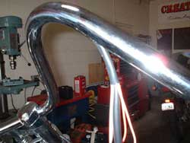
One of the best mod for your motorcycle is drilling stock or custom handlebars to allow the control switch wires to be run internally. This can be a nice way to clean up the ugly black wires tacked onto the outside of the bars and it's pretty easy to accomplish with just a few hand tools. If your motorcycle uses plastic Molex plugs on the ends of the wiring harness, carefully remove each wire with an electrical pin tool and label each wire as to where it goes. Here's what you need: Electric Drill, 1/8" 3/8" and 1/2" drill bits, rat tail file, small flat file. A sturdy vise is great too; I clamp the bars between wood blocks to prevent marring.
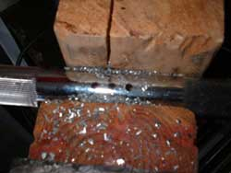
With the bars off the motorcycle, the first step is to drill all the pilot holes with the 1/8" drill. Put one 1/8" pilot hole at the inside of each handlebar dimple and three 1/8" holes in the center of the bar, bottom side where you want the wires to exit between the risers. Next use the 3/8" drill to open up all the holes a bit. The center 3 holes should be close enough to each other that you can turn it into a slot by rocking the drill a bit or using the rat tail file to make a slot. When the slot is nicely formed use the flat file to deburr the edges and smooth the inside so the wires won't chafe. Now use the 1/2" drill on the holes in the dimples to enlarge them and by angling the drill you can elongate the hole a bit so the wire will slide in easily. Deburr the end holes with a file and check internally and externally with your finger for sharp edges.
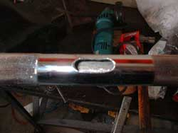
The switch wires should slide through easily and you can fish each end out of the slot with a pick or needle nose pliers. That's it! The rest of the job consists of wiring or in the case of plug ends, putting the pins back in the correct holes. If you have changed the stock bars to higher or longer ones are sure to get some pre-made multi-color harness ahead of time to splice in for the extra length needed.

