Adjusting Carbs For Re-Jetting
(Procedure written for an Intruder 1500 LC)
NEWLY UPDATED: APRIL 2003

Courtesy of: Half-Crazy
SECTION ONE: Get Prepared - Tools
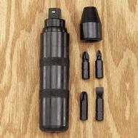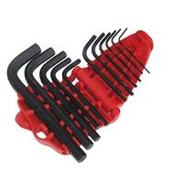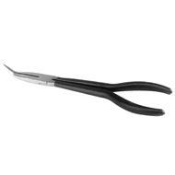
Get a manual impact driver (the kind you hit with a hammer) and a good #2 Phillips bit. The screws around the fuel filler (3) and the screws on the carb vacuum caps and float bowls will most likely just round off without one. This is a good tool to invest in for other projects as well.
Get a good set of metric Allen wrenches. As you know, the fasteners are not the highest quality and good tools will help to get them out and back in with a minimum of rounding/stripping.
Get a good pair of needle nose pliers. The skinnier, the better.

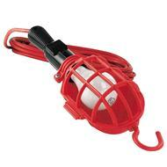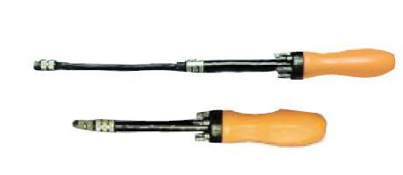
Get a good flashlight or work light. You will need this to inspect that things are seated and back together right during re-assembly.
Get an extendable magnet tipped screwdriver with interchangeable tips. Without a tip, it extends out to about 16 inches --- great for retrieving those little screws and bolts which always seem to fall where nothing else can reach.

SECTION TWO: Disassembly
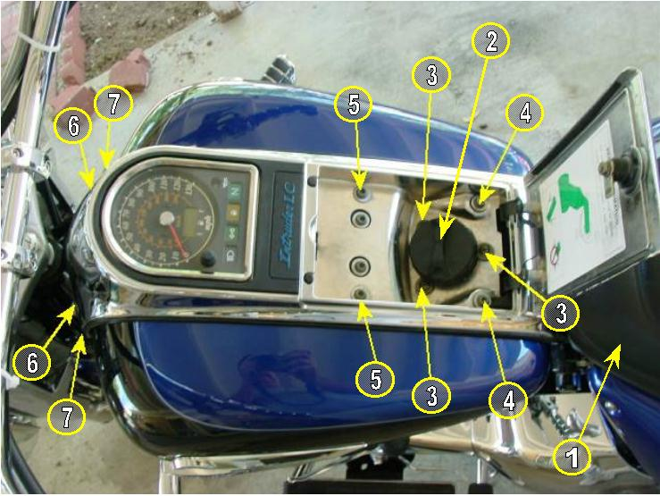
- Remove the driver's seat: Remove the two allen head screws from beneath the lower rear of the seat, and the two 10mm bolts from the lower front of the seat (the one on the left holds the choke control on), and carefully lift the seat off.

- Open the gas door and remove the gas cap. Stuff a paper towel in the filler hole to prevent small pieces from falling into the gas tank (IMPORTANT!!).

- With the impact driver, remove the 3 Phillips head screws around the fuel filler (once you've had them off a screwdriver is sufficient). Take the screws and all washers etc. off together and place them head-down to keep the parts together.

Hint: LAY OUT ALL THE PARTS ON A FLAT SURFACE IN A MIRROR IMAGE OF HOW THEY GO ON THE BIKE. SET THEM HEAD-DOWN WILL ALL WASHERS, SLEEVES, RUBBER RINGS, ETC ON THE BOLTS.
Warning: Any parts you drop will disappear forever, and any parts left in place will vibrate off if you start the bike with the covers off.
- Now remove the 2 allens behind the fuel filler.

- Now remove the outside 2 allens in front of the fuel filler.

- Now remove the steering head covers (one allen each).

- Now remove the 2 allens at the front of the dash.

ARE YOU LAYING THESE OUT LIKE THEY GO BACK IN ON A FLAT SURFACE?
OK, now the dash is free.
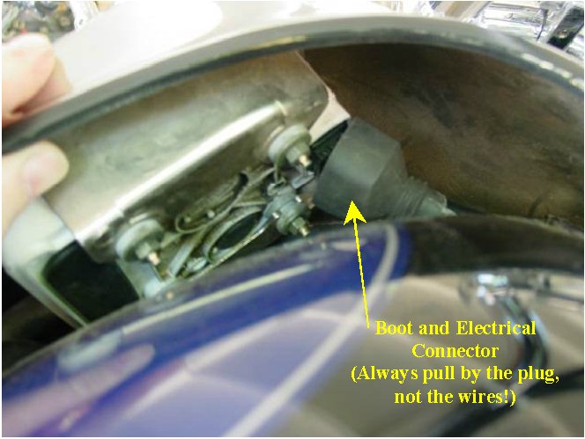
Lift the front of the dash up and feel under the front of the Speedo for the big multi-pin connector with a rubber boot around it. Roll back the rubber and grab the front and rear of the connector with your finger and thumb and squeeze it. It will wiggle off. Lift the dash off the fuel filler and lay it someplace safe.

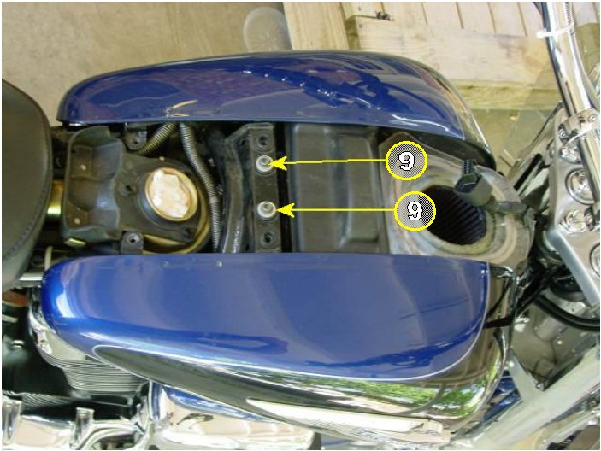
Now there is one allen bolt holding each "tank" half on the bike. One at a time, take out the screw and TAKE THE SLEEVE / WASHER WITH IT, remove the tank half and lay it in a safe place.
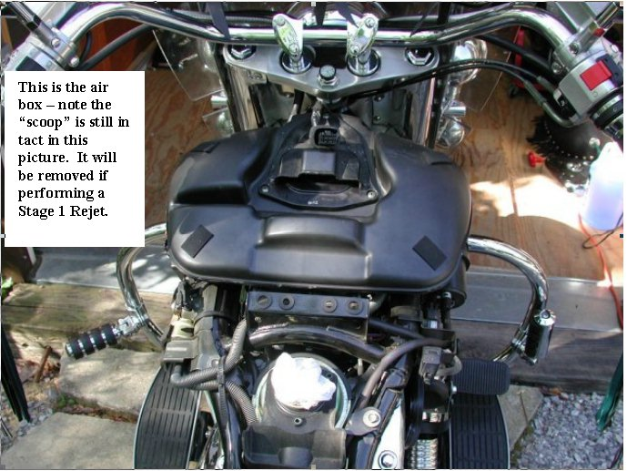
The air box is now exposed…
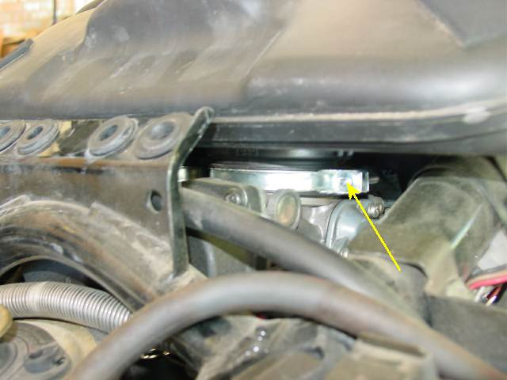
The air box is removed by loosening two clamps that are accessible from the rear (seat side). Once the clamps are loose the air box will lift off.

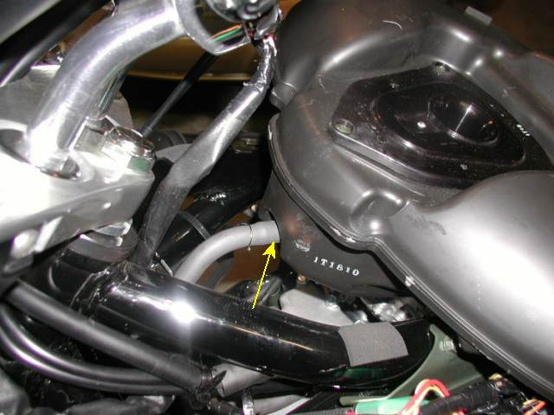
There will be a hose on the front of the air box for the crankcase vent, and another on the right side (if you have a PAIR valve, I don't). Lift the air box a bit, remove the rubber hose(s) and place the air box upside-down in a safe place.

Look, there's the carbs!!!!! We're rockin' now!!!!!!
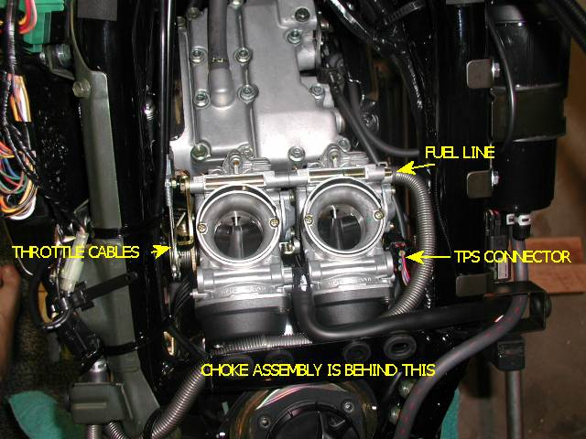
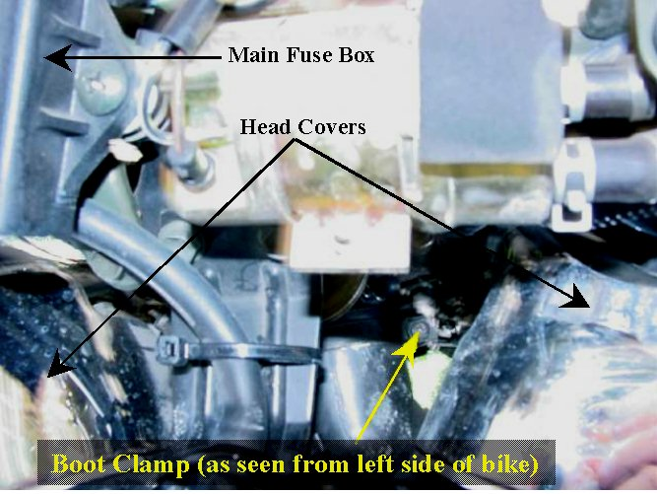
Loosen the two boot clamps that hold the carbs on. They are accessible from the sides with your LONG Phillips screwdriver.

Once the clamps are loose, pop the carbs up off the boots BUT LEAVE THEM LYING ON TOP OF THE BOOTS. This will prevent pieces from falling into the intake manifold.
Pull the fuel line clamp back some and take the paper towel out of the fuel filler (The fuel line is the one with the metal spring protective cover around it).

Pull the fuel line off and drain it into the fuel filler hole.

REPLACE THE PAPER TOWEL IN THE FUEL FILLER HOLE.

Squeeze the sides of the electrical connector on the right side of the carbs (TPS) and it will wiggle off.
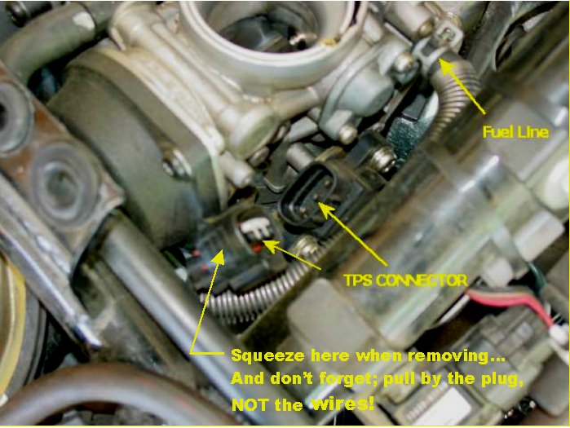

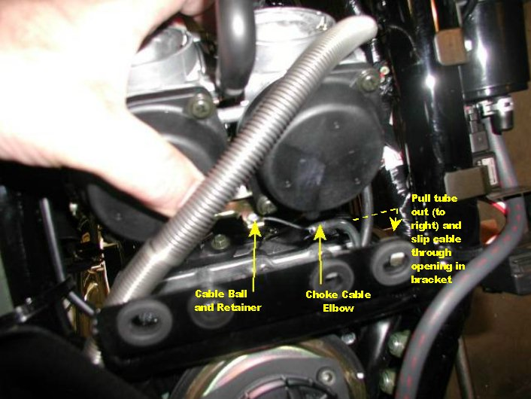
Lean the carbs forward and find the choke cable. Pull the metal elbow of the choke cable to the right and slide the cable out of the slot in the mount. Now rotate the cable forward and remove the cable ball end from its retainer.
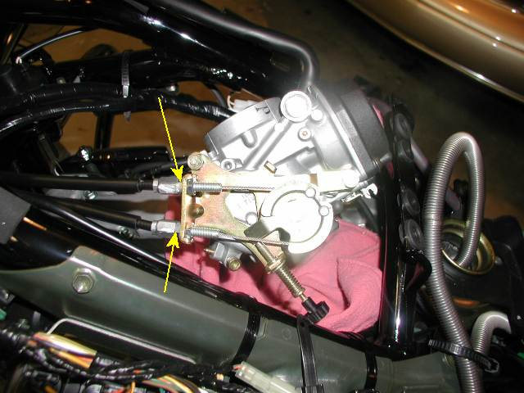
Lay the carbs back on the boots. Take a 10mm wrench and loosen the adjusters on the throttle cables enough to slip them out of their retainers. Rotate the top cable's ball end out of its hole and pull the top cable out through the steering head area of the frame on the right side (so you'll know which is the top cable later).

Remove the lower throttle cable the same way and let it lay.
The carbs are off. Cover the intake boots with a clean rag. Clean the outside of the carbs, especially if you're gonna open them up.
SECTION THREE: Rejetting, We're going in!

Since you are opening up the carbs, I'll assume you are rejetting. If you have the stock air box, rip the little air scoop off the top of the air filter. If it won't pull right off, then cut the plastic rivets with a chisel or drill the heads off. Be careful to keep the shavings away from the opening. DON'T REMOVE THE SCOOP IF YOU ARE NOT REJETTING AND HAVE AFTERMARKET PIPES OR DEBAFFLED STOCKERS. IT WILL CREATE A LEAN CONDITION.

Phase 1 – Shimming the Needles

Place the carbs on a flat surface and put a towel or something soft under them. Lay the carbs bowl down so the black plastic vacuum caps are on top. WORK ON 1 CARB AT A TIME.
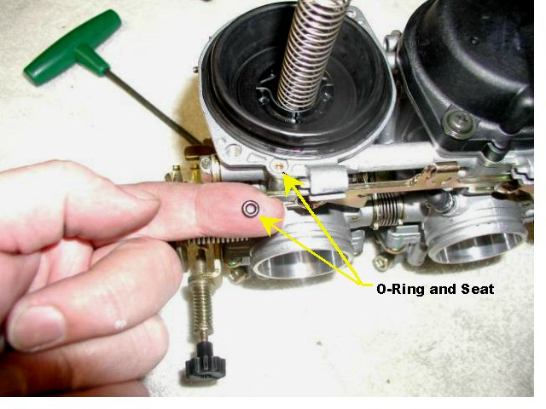
With your Phillips impact driver, break the 2 screws loose. The cap is under spring tension, so hold it down as you remove the screws. Gently let the cap come up until the spring tops out. THERE IS A TINY O-RING OUTSIDE THE GASKET SURFACE ON THE PERIMETER OF THE CAP.
The o-ring will either be stuck to the cap, or laying on top of the carb. Set that little bugger someplace clean and safe so you don't lose it. Take the cap off and pull the spring out. Lay these aside.
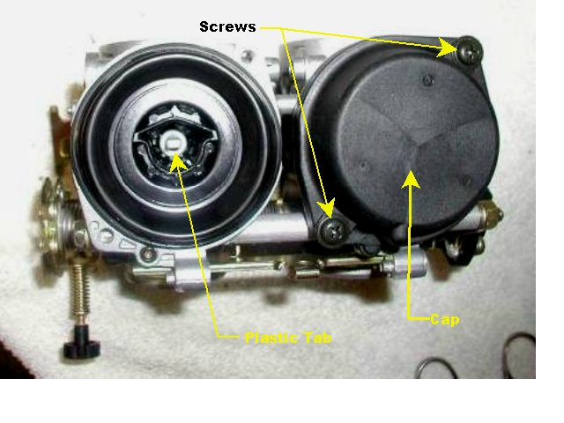
Now you are looking at the top of the vacuum boot and can see down into the slide. At the bottom center of the slide there is a little plastic tab sticking straight up. With your finger on the edge of the plastic slide, hold the slide down, grab the little center tab with a pair of needle nose pliers, and pull it straight up gently. It will POP out. There is a small spring under it, so be careful not to let the spring go BOING and get away from you.
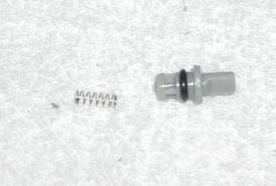
Take the little plastic piece and its spring, put them together as an assembly, and set them aside.
Now it gets tricky. We don't want to change the shape of the vacuum boot if at all possible. It is formed to fit in its groove around the perimeter of the carb body and has gotten comfortable there. Unless you are wanting to inspect the emulsion tubes for wear, it is best not to break the seal between the vacuum boot and the carb.

We'll do it both ways.....

7a. Not breaking the seal:
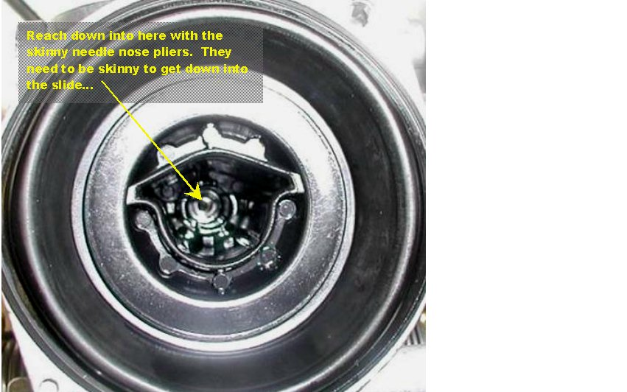
With a skinny-assed pair of needle nose pliers, reach into the bottom of the slide and grab the top of the needle. Hold the slide down and pull the needle straight up and out. The needle has a retaining clip "E-CLIP" to retain its height position. Below this clip (long end of the needle) is a thick, white plastic washer, above this clip is a thin metal washer. Keep these parts together.
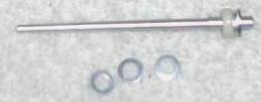

Skip To ***Alrighty Then***
7b. Breaking the seal:
The Vacuum boot's upper edge is sort of shaped like an upside down "U". On opposite sides, pinch the boot between your thumbs and forefingers and gently pull it up out of its groove on top of the carb body. The slide will pull out with it. Now you can push the needle up from the bottom and take it out with your fingers. The needle has a retaining clip "E-CLIP" to retain its height position. Below this clip (long end of the needle) is a thick, white plastic washer, above this clip is a thin metal washer. Keep these parts together. Place the slide assembly vacuum boot up (like a mushroom) on a flat surface. Now you can look into the carb with a light and inspect the hole where the needle came out. If the hole is not perfectly round, you have a serious problem. If all is well, replace the slide in the carb and let the vacuum boot slip back into it's groove, nice and easy like. It should go right back in place.
*** ALRIGHTY THEN ***

THE FRONT CARB HAS THE ELECTRICAL CONNECTOR ON THE SIDE OF IT. THE REAR CARB HAS THE THROTTLE CABLE ASSEMBLY ON THE SIDE OF IT.
***** If you are shimming the stock needles: Slide the thick plastic washer off the long tapered end of the needle. Place the desired shims over the long end of the needle (One 1/2-step washer ought to do it). Slide the plastic washer back into place against the e-clip, sandwiching the shims in between. Put the thin metal washer over the short blunt end of the needle and slide it up against the e-clip (if you took it off). Gently drop the needle back into the slide and through it's "tube".
8. Take the little plastic tab and spring combo that held the needle down, Grip it with the needle nose pliers, and press it back into place STRAIGHT DOWN. Be sure that it is seated all the way and completely vertical.
9. Find that little o-ring that we set in a safe place. Put it in its little spot outside the vacuum boot perimeter.
10. Place the long spring down in the center of the slide.
11. Place the vacuum cap on top of the spring where the cap has a knob that slips inside the spring. BE SURE THE CAP IS FACING THE RIGHT WAY TO LINE UP WITH THE BOSS FOR THAT LITTLE O-RING. YOU KNOW, THE ONE WE TOOK SUCH GOOD CARE OF.
12. Push the cap STRAIGHT DOWN onto the top of the carb being careful not to disturb the seal on the vacuum boot. Hold the cap down with your fingers and put the Phillips screws back in snug. Torque the screws
13. Repeat Section 3 procedures for the other carb.
Now, See how easy that was?????

Rejetting, Phase 2...Float bowls.

Flip the carbs over so they sit flat on the vacuum caps, bowls up, on something soft (like a thick towel). Work on one carb at a time.

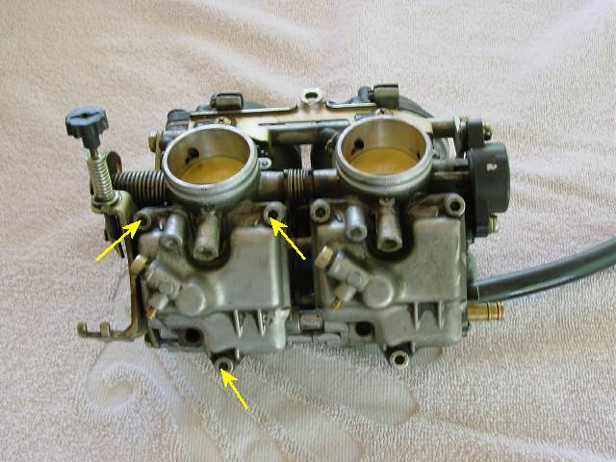
With the Phillips impact tool break loose the screws holding the bowls on.

Remove the screws on 1 bowl and pull the bowl off carefully, straight up. There will probably be some varnish in the bottom of the bowl. Clean that out with some carb cleaner or some solvent and dry the bowl completely.

Inspect the gasket (o-ring??) of the bowl for damage (It should be OK).
There are 2 jets protruding from the carb body into the bowl. The shorter, fatter one in the center is the main jet. The longer, skinnier one off to one side is the pilot jet. The jets have a slot head on the end for removal with a screwdriver.

Use a screwdriver that fits tight in the slot and is not too small, so you don't chew up the jets. Carefully unscrew the main jet and replace it with the desired size jet.

Next, unscrew the pilot jet and replace it with the desired size. Don't be a gorilla fist and strip the threads out or mangle the jets up.

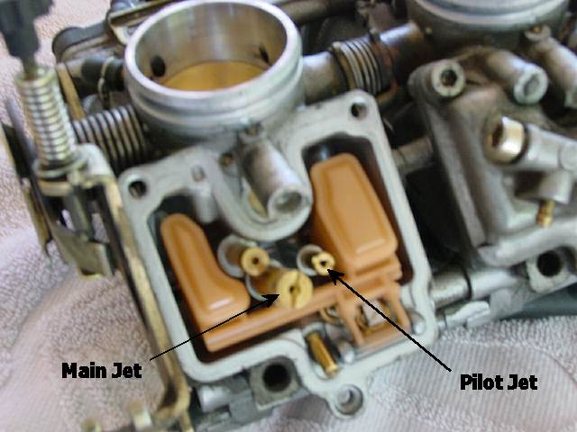

If you want to check/adjust the float level (a good idea) follow the procedure in the manual (it has pictures!).
When you are done putzin' around in the bowl, simply slip the bowl on carefully and tighten the screws up. Repeat the procedure on the other carb.
SECTION FOUR: Mixture screws:

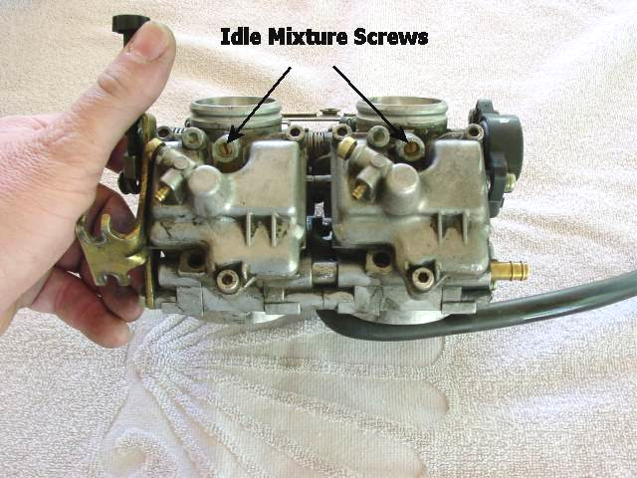
On the float bowls there are 2 plugs, brass colored, with pinholes in the centers. These are covering the mixture screws. Lay the carbs on something soft and tape off the open ends of the carb throats with masking tape to keep the shavings out of there.

Note: The picture at left shows the screw locations. The caps have already been drilled out on this set of carbs.

Gently drill out the plugs with a 1/8" bit, being careful not to hit the screws below.

Once you have holes drilled through the plugs, screw a sheet metal or drywall screw into the hole. Grab the screw with pliers and wiggle the caps out. Sometimes if you just tighten the screws with a screwdriver the caps will come right out, but you are bottoming out on the mixture screws to do this, so BE CAREFUL.

Clean up all the metal drill shavings, unmask the openings, and lay the carbs on a clean cloth.

Get a small slot screwdriver that will reach into the holes where the screws are, without touching the sides. Take a black magic marker and mark one edge on the screwdriver blade (so you can see complete turns easily). Tighten the mixture screw slowly until it LIGHTLY seats. DO NOT TIGHTEN ANY MORE THAN LIGHTLY SEATED.

Open the mixture screws slowly and count the 1/2 turns (2 half turns will bring the mark back around) 1/2.... 1.... 1-1/2.... 2.... 2-1/2.... 3 etc. The number of turns will depend on your pipes and other factors.

SECTION 5: Re-assembly

The carbs are clean and the intake manifold boots are clean, right?

- Loosen the carb clamps up about 3/4 of the way out. Position them so the screw heads are facing out the sides of the bike.
- Lay the carbs on top of the boots the way they go, but don't push them on yet.
- Put the bottom throttle cable on and tighten the adjuster all the way up. Pull the top throttle cable back out of the frame and put the cable on.
- Tighten the adjuster all the way up (Both throttle cables adjusters should be all the way closed, maximum slack position). Check throttle operation.
- Roll the carbs forward and find the choke cable.
- Put the ball end in it's retainer then pull the metal elbow tube to the right, slip the cable back through it's slot, and let go.
- Lay the carbs in place again and CHECK THE CHOKE OPERATION.
- Connect the electrical connector to the TPS. (Right side of carbs)
- Connect the fuel line (make sure there's no kinks).
- Run the carb vent hose over fuel line to the right and stick it through the square frame tab, pointing downward.
- Line the carbs up with the intake boots and push them down until they pop in. Take a light and inspect that the carbs are all the way seated, all the way around. Hold the carb clamps in place from behind (seat side) with your long slot screwdriver as you tighten them with your long Phillips.
- Tighten the clamps all the way closed until they bottom out.

OK, the carbs are on. Make sure there are no tools or fasteners sitting on the bike anywhere.

- Pull the paper towel out of the gas filler and replace the gas cap. Turn on the key and fire the bike up. It should start right up like normal. Don't run it long, just make sure she starts up. Shut it off.
- Take the gas cap off and put the paper towel back in the filler hole.
- Open the air box boot clamps 3/4 of the way open. Make sure the screw heads are pointing toward the seat (back).
- Lay the air box on top and connect the breather hose in front and PAIR valve hose (if you have one). Make sure the multi-pin for the dash is on top of the air box. Line the air box up with the carb throats and press it into place.
- With a light, inspect that the air box is all the way seated, all the way around the carbs. Hold downward and rearward on the air box while you tighten the clamps. If you tighten them too much they will pop off the carbs. Snug them down and make sure that when you wiggle the air box the carbs move too, and it won't pop off.
- Put the seat on and replace the gas cap.
- Ride the bike for a while. See how it runs. If you are satisfied with the way it runs, double check that all the carb boots and air box boots are secure in preparation for buttoning up the "tank" and dash.
- Pull off the gas cap and put the paper towel back in the filler hole.
- Take each tank half and wiggle it into place.
- Put the top inside bolts in (the ones with the metal sleeve/washers) but leave them loose.
- Set the back of the dash in place and hold the front up while you reconnect the Multi-pin connector and slip the rubber boot back into place over the connector.
- Lay the dash in place; making sure that the filler neck and surrounding isolators are in good position.
- Put the rearmost 2 bolts in (behind the filler neck. (Short bolts, just washers) finger tight. Put in the front dash bolts (behind the steering head) and tighten them up. Put the steering neck covers back on and tighten them up.
- Put in the last 2 bolts in front of the fuel filler (the ones with all the rubber stuff on them). Tighten all 6 allen bolts around the fuel filler (4 in front, 2 in rear). Put the 3 Phillips screws around the fuel filler in and tighten them up. Remove the paper towel from the fuel filler and replace the gas cap. Close the fuel door with the key.
You're done. Go riding.

