Harley-Davidson Ignition Switch Installation:

Parts List:
- Ignition Switch
  - Harley Davidson
    - P/N 71313-96
    - P/N 71510-93
  - Drag Specialties
    - P/N DS-272187
  - JP Cycles
    - Cat # 370333

- Nuts and Bolts
  - For Switch Mount:
    - 4x 6-32 (Chrome or SS) countersink screws
    - 4x nuts for above
    - 4x washers for above
  - For Door Locking Mechanism:
    - 5/16-18 Bolt (or stud)
    - 2x 5/16-18 nuts
    - Block of rigid material
      - Dimensions: 5/16” x 9/16” x 3/8”
      - Material: Aluminum, Stainless Steel, PVC, etc (Anything rigid will do)
    - 5/16-18 Tap
    - Series of drill bits up to 9/32” (drill size required for 5/16-18 tap)
    - Roll (or Spring) Pin and drill bit 1/32” smaller than pin

- Wires and Connectors
  - 14 gage wire – Red, 15 inches long
  - 14 gage wire – Orange, 15 inches long
  - 14 gage wire – Grey, 15 inces long
  - 14 gage wire – Brown, 15 inches long
  - 14 gage Female Wire Terminals (x3)

- Miscellaneous
  - Radio Shack
    - 100 Ohm Resistor (1/4 Watt, 5% Tolerance) – P/N 271-1108
    - Also recommended – piece of PC board to solder wires and resistor to
  - Heat Shrink Tubing – Pack of Assorted Sizes
  - Duct Tape or Masking Tape
  - 6” (or longer) Zip (Cable) Ties

Tools and Equipment List
Safety Goggles | Leather Gloves
#3 Phillips Screwdriver and Allen Wrenches for Removal of Seat and Instrument Panel | Ø 1-3/4” low speed hole saw (metal cutting variety)
1/8” Drill Bit | Ø 1-1/2” diameter drum sander (to fit hand drill)
¼” Drill Bit or Countersink Bit | Wire Cutter and Crimping Tool
Soldering Gun and Solder | Measuring Tape and/or Ruler
Drill or Drill Press (Preferred) | Patience

Got everything gathered up? Good!

At this point it would be a good idea to remove the door from the bike. Open the fuel door and remove the screws that attach the hinge to the door (at the bottom). A word of warning…the screws that hold the door on are about as hard as warm butter, and Suzuki likes to use lots of locktite on the screws. Chances are you will demolish the screws when you take them out, so have some stainless replacements handy to replace them with!

The first picture shows you the infamous “aluminum block”. This block could be any kind of metal: steel, brass, copper, bronze, or even hard composite material like PVC (the softer the better). I think Larry (Jhawk on the forum) called it aluminum, and the name stuck.
The block needs to be 9/16” long, 5/16” wide, and 3/8” high. None of these numbers are etched in stone; obviously they can’t be larger but if you have something smaller it will be OK, length and height are not critical. But, if you have something narrower you can fill up the gap with plastic shims or even Duct-tape, I guess that is why they call it “Custom made”.
In this pic, you can see the parts required for fuel door locking mechanism: the block, jamb nuts, stud (which is actually a 5/16-18 SS Bolt with shank and head sawed of), locking latch, and rolled pin. Stud and Jam Nuts are all 5/16-18 but you can use any size from 1/4 inch all the way up to 3/8. I picked that size since it is the most common fastener size in hard ware stores.
BTW I don’t know why they look like Copper in the picture but they are all Stainless steel. See you at next post

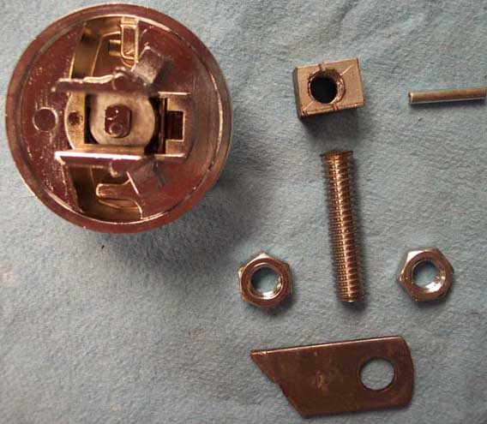

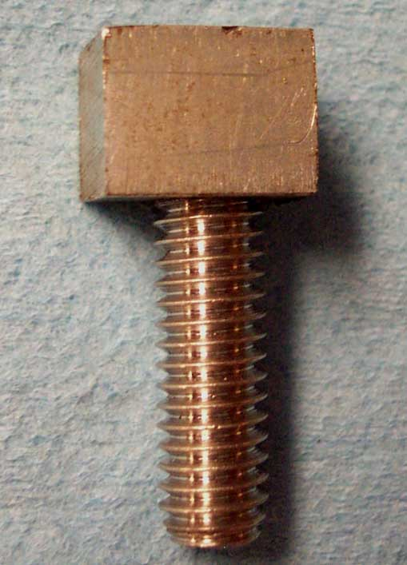
Ok, the 5/16-18 stud will require 9/32 drill bit, but I would start with smaller pilot hole and go up in size in three steps.
When I was installing the stud in the block, I used some red Lock-Tite…not to secure it in there, but to stop it from rotating while drilling for the Rolled pin. After you insert the rolled pin in, that baby is not turning under any circumstances.
Now you have a Bolt that resembles letter T, which it’s head will rest between the EARS on the HD Switch housing. Here is the Pic.

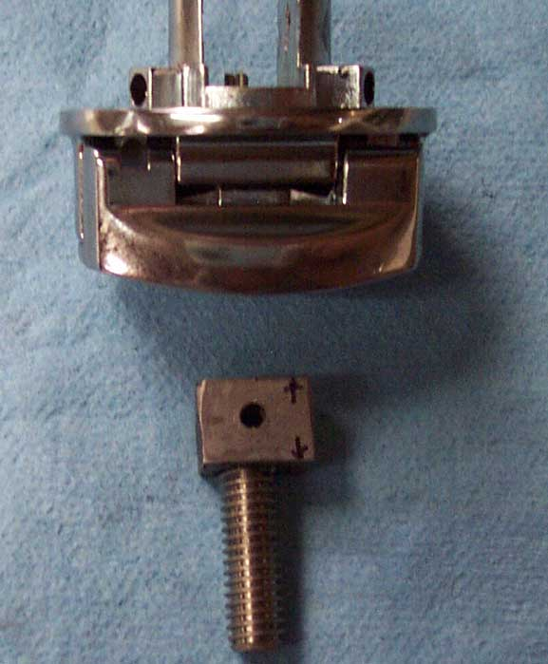
This pic shows you the hole for the rolled pin. You insert the block in the center of the switch housing and drill the hole through all 3 parts at the same time. I removed it after drilling for the photo only.

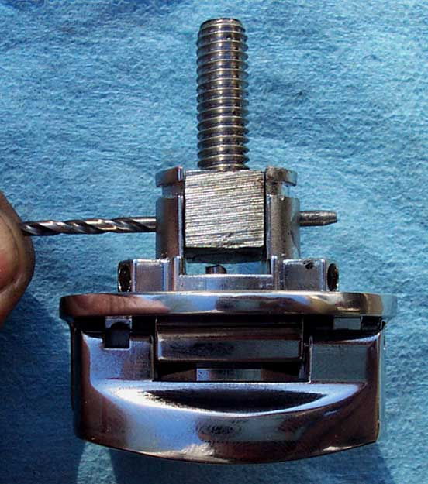
The drill bit size for the Rolled pin depends on what diameter pin you are using. Whatever that measurement is, pick a bit 1/32 smaller. This picture will show you where the pin will be installed (drill bid is for demonstration).
IMPORTANT...remember to install the locking latch and spring (you will exactly know which Latch and spring I'm talking about when you disassemble your HD switch) under the Block and Stud before inserting the Pin.
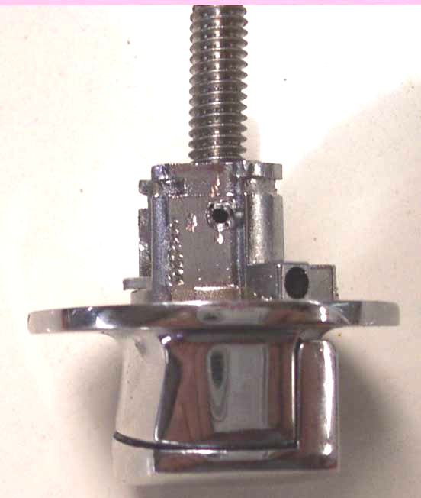
Ok, here it is; install the locking latch and spring, then rest the block and stud between the switch’s tabs. Line up the holes, and drive the pin through.

Grind and smooth out both end of the rolled pin flush with Housing's sides. Now you are ready to set this baby aside.

Time to drill the BIG hole!

Before you get too far into this, be sure to cover the entire door with a couple layers of duct tape (or some other sturdy adhesive covering). This will keep the chrome from getting scratched up while you’re drilling. Notice the duct tape in the picture here.

This picture shows you some very important elements. As you see, I'm using a hard wood backing plate to have my hole saw's pilot bit to ride in. This is because the pilot hole falls inside the existing door lock hole, not the door itself (you will see this in an upcoming picture).

Since I don't trust wood as a solid base, I sandwiched a thin sheet metal between the Fuel Door and Wood then clamped all 3 together.
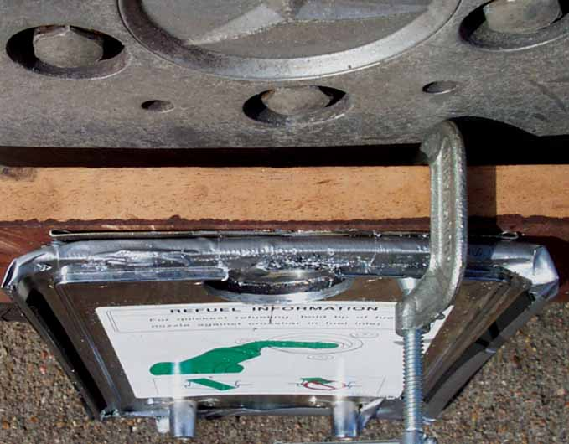

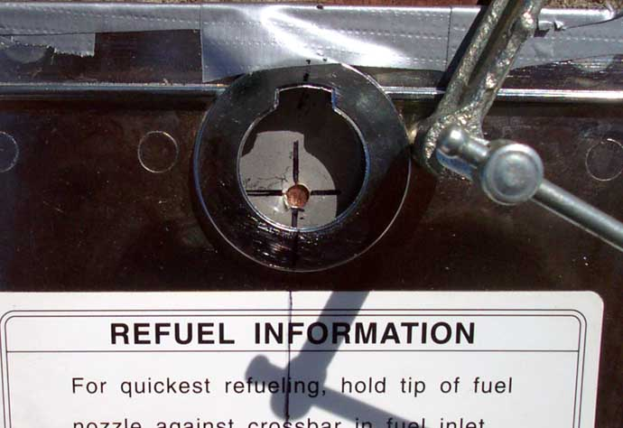
See how the pilot hole doesn’t end up on the door, but in the existing door lock hole? That’s why we sandwich a piece of steel in between!

I used 1–¾” hole saw to do this, which is tad smaller than the new switch's OD. Then I used a 1–¾” drum sander bit chucked on a hand-held drill and fine-tuned this hole until the switch housing just passed through. Randy (Bushwhacker) says he used 1–7/8” hole saw and result was perfect…you might try that. As I said, dimensions are not that critical.

Your Center Punch should rest 1/4 of the diameter above 6 O'clock position of the existing hole. OK, if you don't think that I'm clear at all, you are right! That’s why I'm getting help from pictures (again this 1/4 thing is NOT critical). Put the dent right there and drill your small pilot hole.

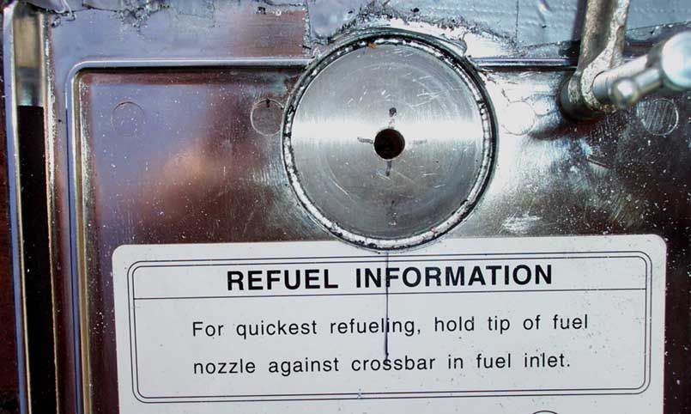
The scary part is done! What you see in back ground through the big hole is the Thin Sheet Metal backing plate, which at this point it has outlived its usefulness.
By the way, have you noticed that up to this point, the black sticker on the top-side of the fuel door was not disturbed? This is so it has the same hole as the fuel doors metal portion. Now you don’t have to try to match the holes afterward!

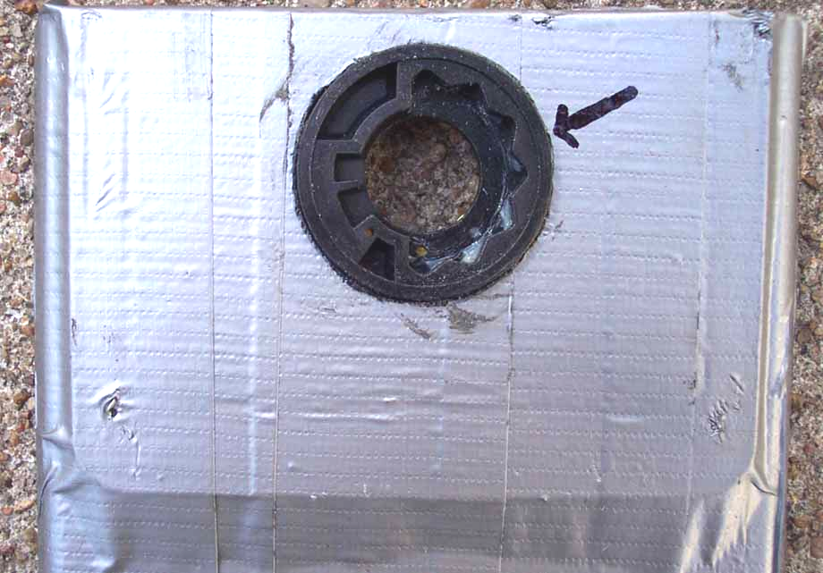
Give the switch a trial-fit through the new opening.
Notice here the duct tape we mentioned earlier covering the entire fuel door. You didn’t forget to cover the door with duct tape first, did you?
Please take note of the arrow; during final assembly you might want to apply a dab of black RTV or silicone sealer all the way around this spot just to be on the safe side. The fuel compartment was designed to be watertight when Bike left Japan, so we might as well keep it that way.

Now at this point, proceed with peeling off the black sticker. I'm sure you can come up with a good way to do this. I don't how many of these things I have done and so far; I know of only one Chemical that will make removing and cleaning of the sticker residue, and it is called PATIENCE. Just get a wooden spatula and peel it off, then use patience and your fingertips to remove the double-sided tape.

Put center switch housing back in the opening. Using the 4 mounting ears as guides, mark and drill the four 6/32” holes for the screws.

Flip over the fuel door and counter sink holes as you see in this picture. Use a ¼” drill bit to countersink if you don’t have a countersinking bit. The sticker adhesive makes the sticker pretty forgiving of heads that aren’t EXACTLY flush, so just get it as close as you can.
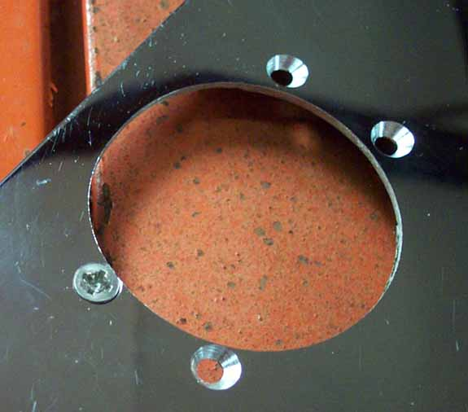
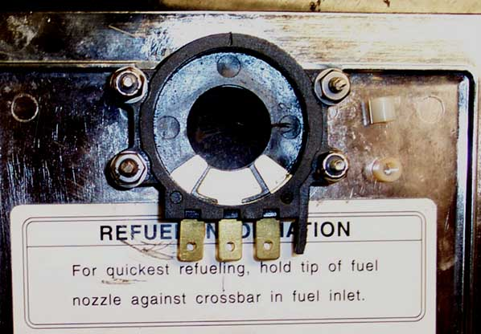
In this picture you can see the type of plastic spacers I used to adjust mounting height of the Switch's center housing.

Basically, the concept is this; when you are done installing and tightening all 4 screws, the top of the housing should be flush with top surface of the black sticker (refer to picture with Duct Tape and Arrow).
1998 and 1999 LCs have paper thin stickers, while late models have thick plastic ones. For the thick ones, I used 3/16” spacers. You can find them at your neighborhood hardware store in many different sizes. I put some extra Spacers in the photo for reference.

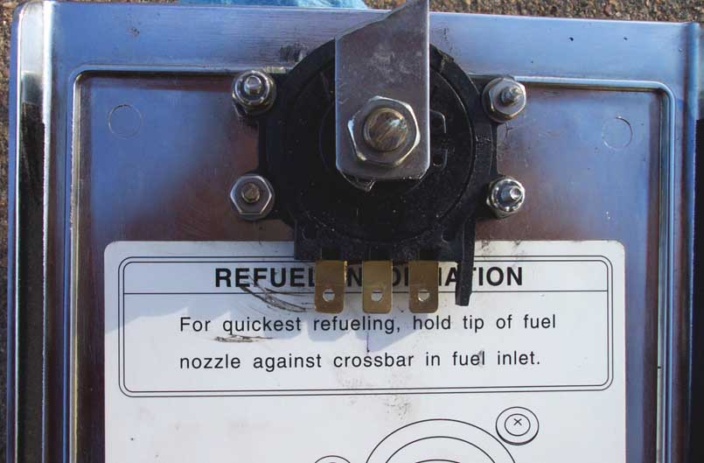
Install the center housing, tighten the screws, and reattach the Black Sticker. Nothing will work better than good old-fashioned double-sided tape here. During assembly of the switch components, use small amount of heavy wheel bearing grease on the tabs and springs. This will retain those Small parts during final assembly, and it is also good for their proper operation and longevity. After you are done with the switch, screw in the bottom jamb-nut, then install the homemade fuel door latch, and finally the top jamb-nut.
At this point the entire Gizmo is ready to be installed on the Bike for final adjustment. Oh yeah…there IS the small process of final adjustment.

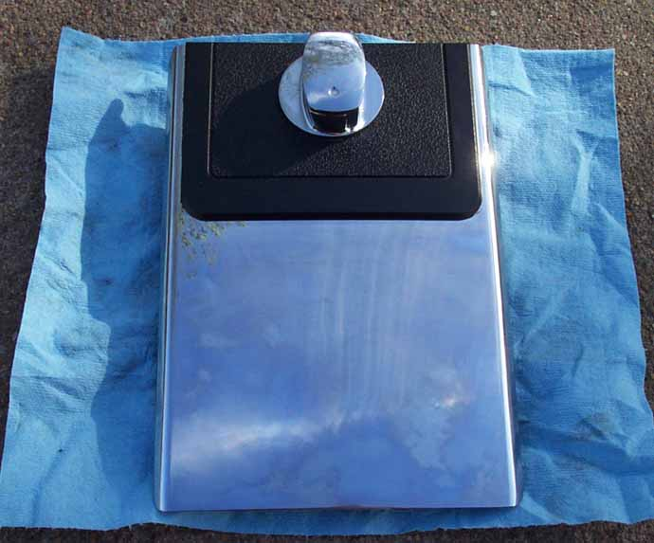
AAAAHHHH what a beauty!
Ready for the rest now?

